Database System Engineering and Distributed Backend Development
WEEK-3
Name: Souradeepta Das
Roll no: 2520030347

INSERT SAMPLE DOCUMENTS

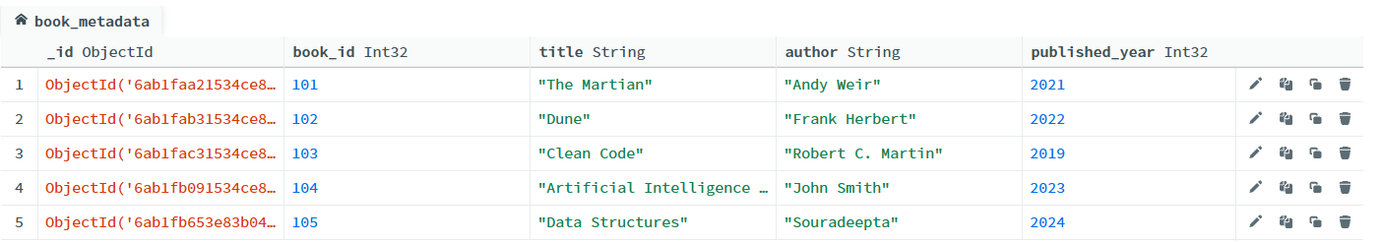

COMPARISON OPERATOR $gt

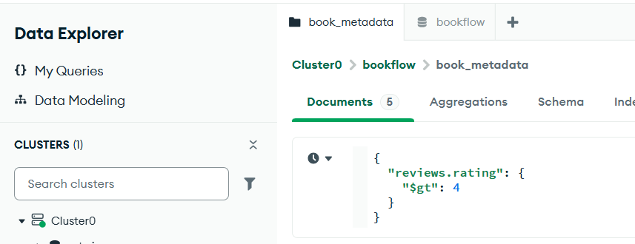
Output

USING $IN
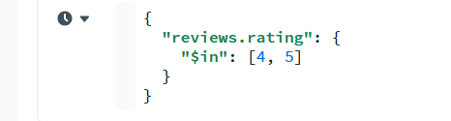
Output

REGEX QUERY
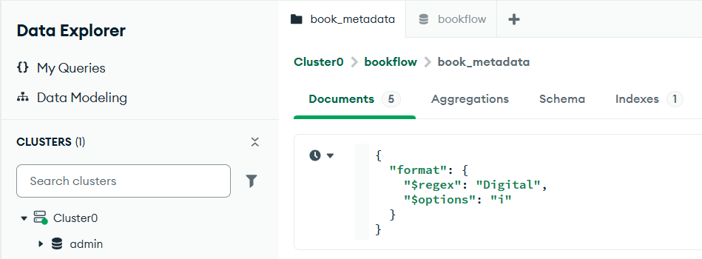
Output
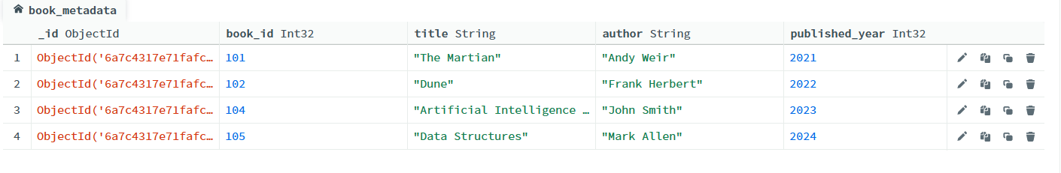

$MATCH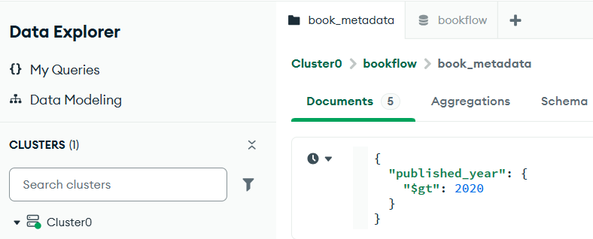

Output
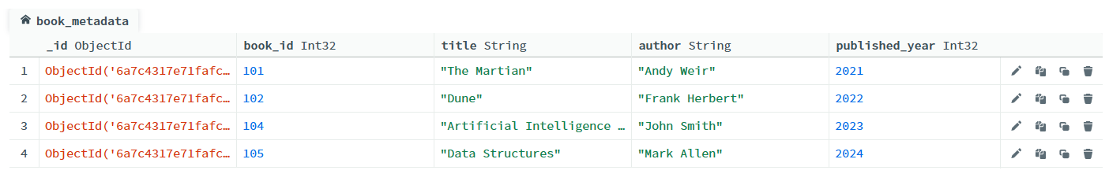

$UNWIND
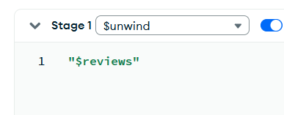

Output
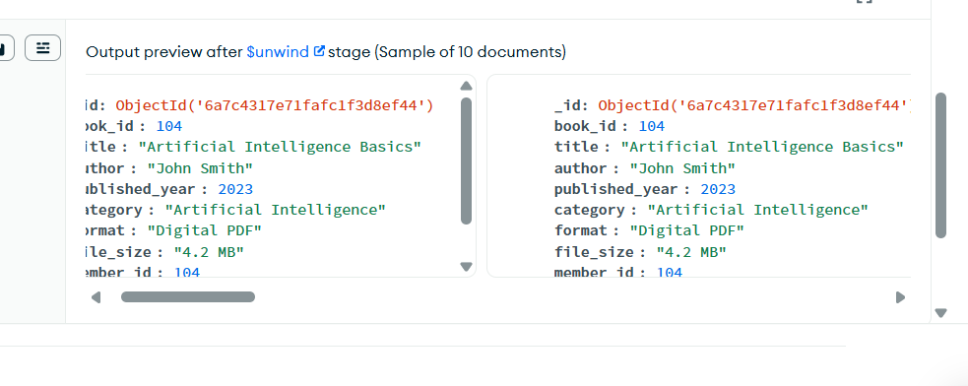

$GROUP

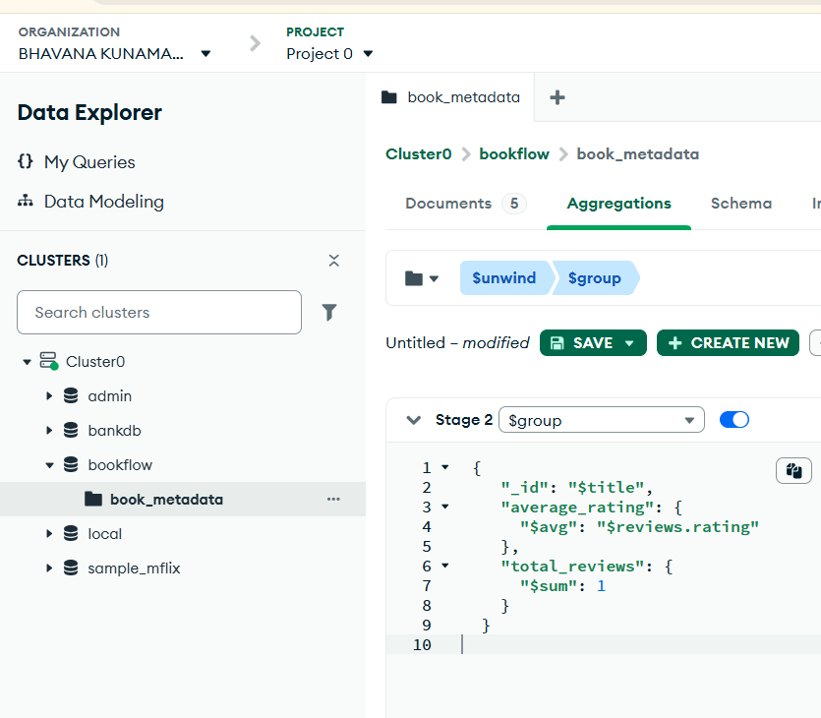
Output
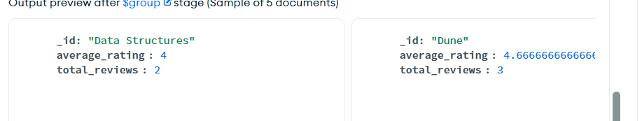

$SORT

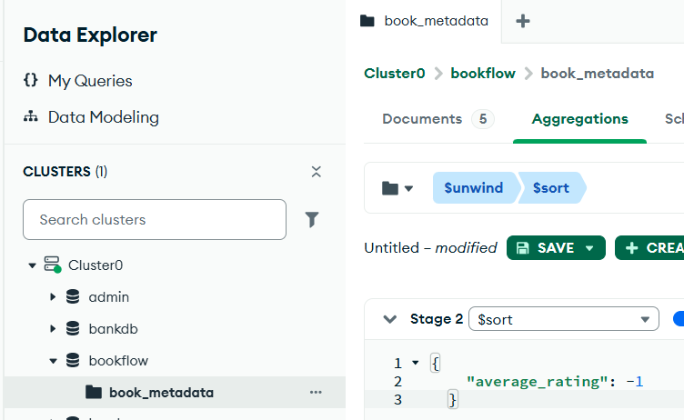
Output
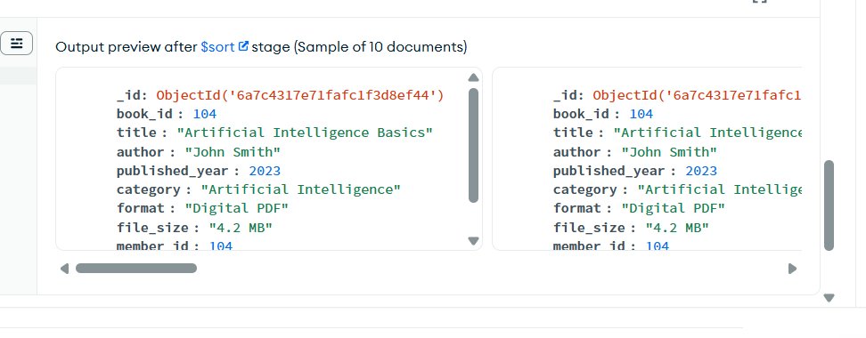

Create index text

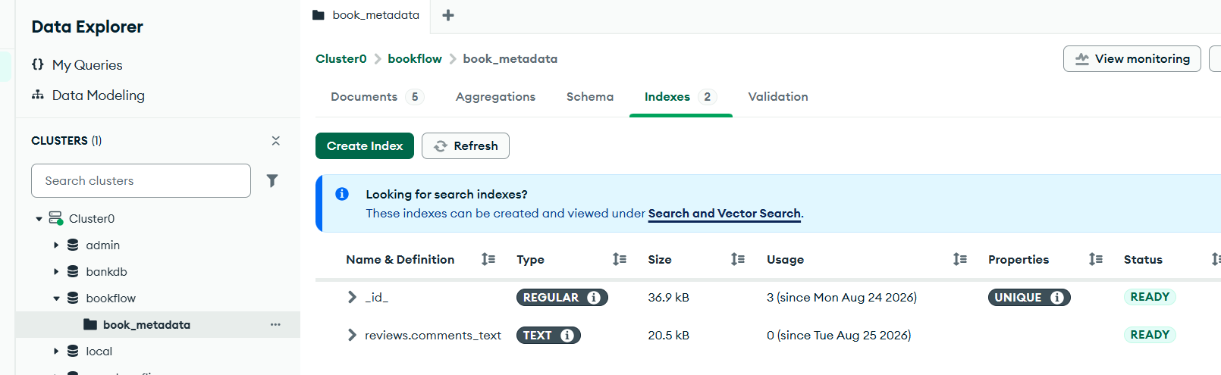

SEARCH USING TEXT INDEX

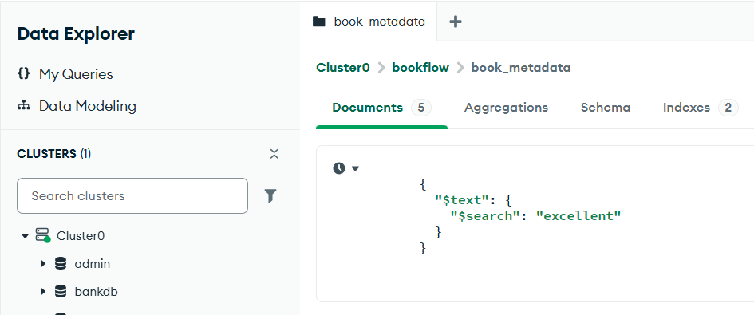
Output
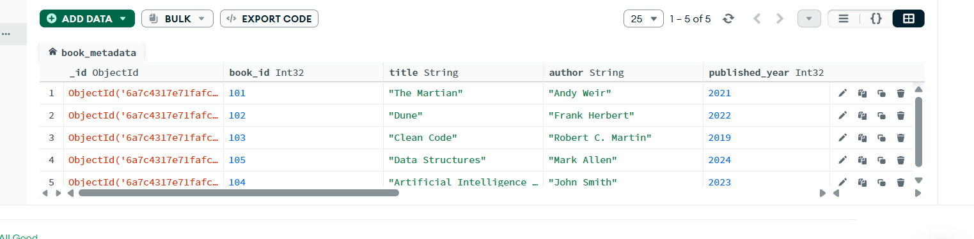

SEARCH FOR A SPECIFIC KEYWORD

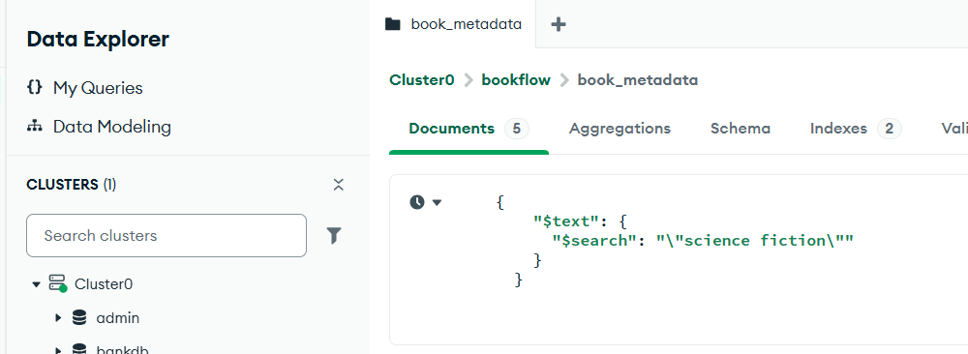
Output
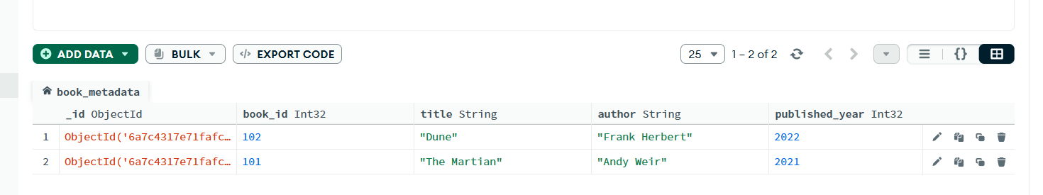

USE explain()

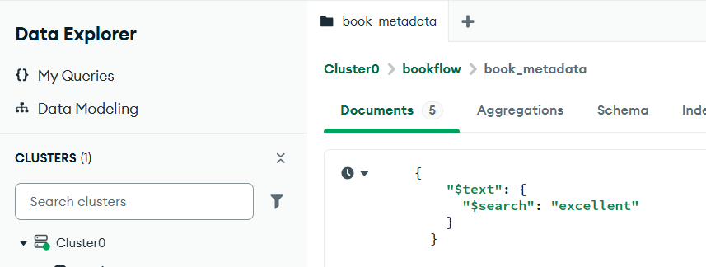

Output
